20XX-01-XXXX

Road Curvature Decomposition for Autonomous Guidance

Author, co-author (Do NOT enter this information. It will be pulled from participant tab in MyTechZone)

Affiliation (Do NOT enter this information. It will be pulled from participant tab in MyTechZone)

Abstract

Vehicle autonomy is critically dependent on an accurate identification and mathematical representation of road and lane geometries. Many road lane identification systems are ad hoc (e.g., machine vision and lane keeping systems) or rely on polynomial approximations of road data and GPS positioning. A novel system is proposed in which geodetic road data is parsed along road directions and digitally stored in a road data matrix. Using mapping algorithms, the road data is converted to a smooth, differentiable path which connects critical road coordinates with curvature vectors and changes to road tangent angles. Different road data sources such as GPS or geographical scans were evaluated with this method and compared to current road design standards as per the American Association of State Highway and Transportation Officials. This approach takes advantage of standard roadway design practices, which rely on speed limit, superelevation, and empirical data for maximum lateral acceleration tolerance to determine acceptable radii of curvature for different classes of roadways. Successful implementation of this technology could accelerate autonomous vehicle’s navigation research and development for new guidance paradigms in addition to traditional machine vision-based systems.

Keywords: Trajectory Generation, Path Generation, Curvature, AASHTO, V2I, Vehicle-to-Infrastructure

Introduction

Most modern approaches for autonomous vehicle operation depend on light sensors, such as LIDAR or machine optics, and object proximity sensors, such as radar, for detecting potential collisions and centering the vehicle in a travel lane. The vehicle must dynamically estimate the vehicle’s instantaneous position with respect to a lane, the uncertainty in the vehicle’s current position (i.e., tolerance), and the vehicle controls required to remain in or rejoin the target path, which is the center of a lane. Therefore, before determining what vehicle controls are necessary to follow a target path, the geometry of the target path must first be identified.

Vehicle Dynamics in Road Design

On board driving during a turn makes the vehicle subject to different road factors that affect vehicle navigation. Tire to pavement friction affect vehicle stability by limiting the amount of acceleration a vehicle can handle before losing control. Superelevation and road crowning increases the possibility of road yaw instability as the speed of the vehicle increases. To study the effect of road design in vehicles, the Ackerman Steering which relates the effect of acceleration and tire parameters on the heading angle of the vehicle during turning. [1] [2]

To take into consideration the dynamic limitations of vehicle, the American Association of State Highway and Transportation Officials (AASHTO) are defined to comply with a range of road designs that permit the maximum allowable superelevation, crowning, and acceleration in between the tires and the road. [3]

Motion Generation in Autonomous Vehicles

In this paper, a path is defined a connection in between two points (i.e. Point A to Point B). While trajectory is defined as the time trace needed to go through that path given different constraints. Given constraints can be in the form of differential constraints from equations of motion, geometrical constraints or dynamic constraints from vehicle limits.

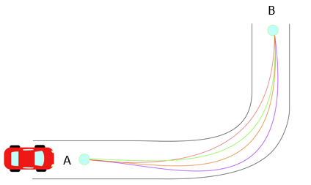

Figure . Different Trajectories in Path from Point A to Point B.

Path Planning

Path Planning can be classified as roadmap-based planning, in which regions of both traversable and non-traversable spaces are explicitly known. Sampling-based planning, which uses sampling from sensors to create a path based on limited data sets. Probabilistic methods, which rely on approximating the free space available for navigation, some examples are known as Probabilistic Road Maps and Rapidly Exploring Random Trees [4][5]. Phase. And Finally Phase Space Planning which incorporates different sampling-based planning algorithms and compares them to extract the most optimal one [5].

These methods rely substantially on the aid of vehicle sensors to generate their navigation map, for example discretizing areas of space from an image and classifying them as either navigation feasible or not.

Trajectory Generation

Literature on trajectory generation explores different ways in which a time-dependent mathematically described curve connecting points is defined. During on-road driving, parameters such as velocity, acceleration dictate the behavior of the curves connecting each point. Different methods used in this area are variational methods, clothoids, and velocity profiles [6] [7] [8].

Variational methods arise from optimizing functionals with non-holonomic constraints (i.e. constraints on the velocity and acceleration) [9]. These methods yield polynomial solutions of high order that are treated as boundary value problems (BVP) during vehicle navigation [10]. Along with variational methods, Clothoid functions (Cornu Spirals or Euler Spiral), and spline functions are often studied in autonomous research because of their effectiveness to connect a straight line with a constant radius curve. Such that both are used for road design and local trajectory generations.

These trajectory methods are then combined with optimization theory to be implemented into controllers for navigation purposes [11]. In general, these trajectories focus on providing a continuous function (up to the third derivative) while being smooth (i.e. minimizing the jerk $\frac{d^{3}x}{dt^{3}}$) [12][13].

However, trajectories can also be generated from offline information that comes from different media such as GPS or geospatial data. Therefore, offline data provides a static calculation of the trajectories a vehicle should have regardless of any sensor error that vehicles could encounter during their trajectory calculations.

The objective of this research study is to develop a deterministic technique for identifying the centerline path of travel lanes using smooth, differentiable, parametric equations and geospatial road data. The rest of this paper is composed of the following sections: Method Formulation, Implementations, Recommendations and Conclusions.

Method Formulation

Reference Configuration

The method presented formulates a point particle dynamics approach describing the vehicle’s motion as it passes through a road. A Frenet-Serret reference frame is used along with unit vectors of N (normal), T (tangential), and B (binormal, out of plane) as shown in Figure 2. For this paper, it is assumed that the vehicle navigates on a 2D Euclidean Space.

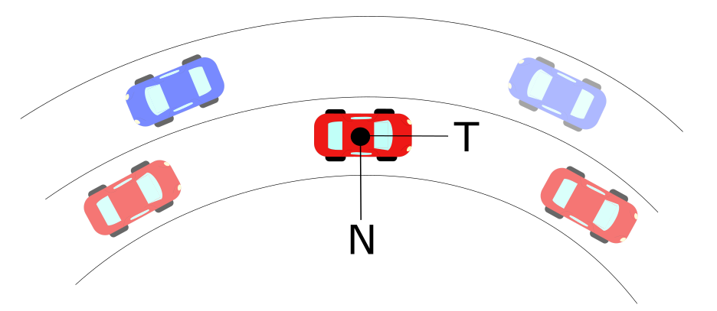

Figure . Normal-Tangential Coordinates Example in Vehicle’s Center of Mass.

As the vehicle goes through the curve, it is limited to constraints provided by road geometry and friction limits on the vehicle tires [1][2]. These limits are related to the acceleration a vehicle goes under circular motion, which is denoted as:

$$a=\dot{v} T+{κv}^{2} N$$

Where:

a = Total Acceleration of Vehicle (m/s2)

v = Tangential Velocity of Vehicle (m/s)

$κ$ = Curvature at an Instantaneous Point (m-1)

N =Normal Unit Vector

T= Tangential Unit Vector

Curvature can be defined analytically, physically and geometrically. It measures how fast the tangential unit vector T changes with respect to an instantaneous point in the curve. Many researchers have been developed on basis of curvature formulation [14][15][16].By Frenet-Serret definition of coordinates, curvature can be expressed in a vector form that has a direction parallel to the Normal Unit Vector shown in Figure 2. Similarly, a vector perpendicular to the curvature direction will provide a velocity tangent vector approximation at that point. This velocity vector provides a heading angle to the desired trajectory that is needed to follow a road path. Thus, it is possible to obtain an instantaneous heading angle representation of any trajectory if curvatures can be obtained from a discrete data set.

Discrete Curvature Formulation

To obtain the curvature from data sets, different methods can be used from geometry, real analysis or differential constraints [14][15]. For this paper, a method from geometry is selected for its low computational cost ($O(n)$) [17].

Let a scalene triangle with corners A, B, C have a circumscribed circle of radius $ρ$ in Euclidean 2D space as shown in Figure 3.

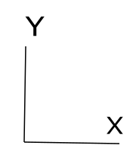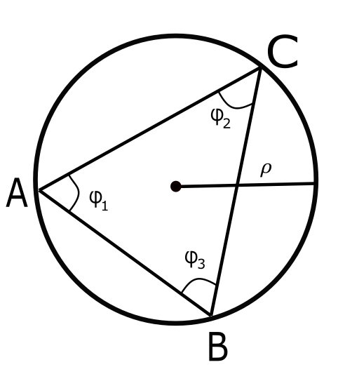

Figure . Circumscribed Circle in Scalene Triangle.

Letting a vector D be the cross product in between the vectors AB and AC, the direction will be pointing out normal to the plane defined by the intersection of AB and AC. Then, the magnitude for cross product:

$$\left\|D\right\|= \left\|AB ×AC\right\|= \left\|AB\right\| \left\|AC\right\| \sin{ϕ_{1}}$$

Let a vector E be the cross product of D with the vector AB, defining this new vector in the direction of $e$ as shown in red in Figure 4. Let the magnitude of vector E be defined as:

$$\left\|E\right\|=\left\|D×AB\right\|={\left\|AB\right\|}^{2}\left\|AC\right\| \sin{ϕ_{1}}$$

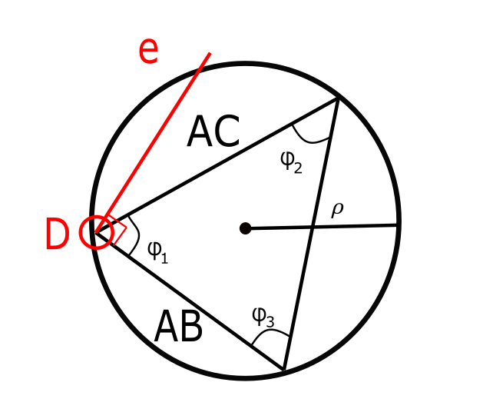

Figure . First Unit Vector Direction on Triangle.

Similarly, let a vector F be the cross product of D with the vector AC, defining this new vector in the direction of $f$ shown in blue in Figure 5. Let the magnitude of vector E be defined as:

$$\left\|F\right\|=\left\|D×AC\right\|=\left\|AB\right\|{\left\|AC\right\|}^{2} \sin{ϕ_{1}}$$

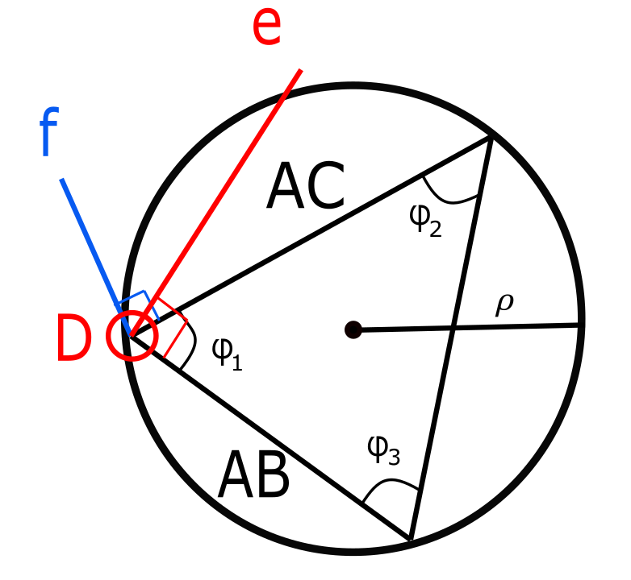

Figure . First- and Second-Unit Vectors on Triangle.

The unit vectors of $e$ and $f$ are defined by the following:

$$e=\frac{E}{{\left\|AB\right\|}^{2}\left\|AC\right\|\sin{ϕ_{1}}}$$

$$f=\frac{F}{\left\|AB\right\|{\left\|AC\right\|}^{2}\sin{ϕ_{1}}}$$

The midsection of any triangle’s side intersects with each other at a point P. These intersecting lines denote two triangles with the same angle $ϕ_{1}$ in between the unit vectors and their corresponding midsections as shown in Figure 6.

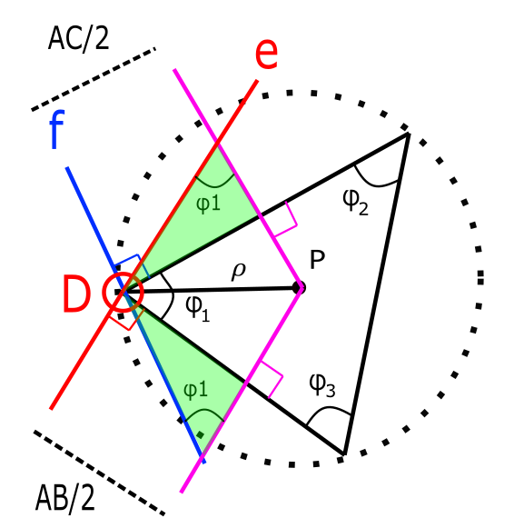

Figure . Radius of Curvature obtained from Geometric Relationships.

From these triangles, break the vector DP into components along unit vectors $e$ and $f$ to obtain a new definition of DP in a different set of coordinates as follows:

$$DP_{1}=\frac{AC}{2\sin{ϕ_{1}}} e=\frac{E}{2{\left\|AB\right\|}^{2}\sin^{2}{ϕ_{1}}}$$

$$DP_{2}=\frac{-AB}{2\sin{ϕ_{1}}} f=\frac{-F}{2{\left\|AC\right\|}^{2}\sin^{2}{ϕ_{1}}}$$

From our previous definition of the vector D, it is possible to simplify further:

$$DP_{1}=\frac{{\left\|AC\right\|}^{2}E}{2{\left\|D\right\|}^{2}}$$

$$DP_{2}=\frac{{-\left\|AB\right\|}^{2}F}{2{\left\|D\right\|}^{2}}$$

With these components, it is possible to obtain the magnitude as follows:

$$DP= \frac{{\left\|AC\right\|}^{2}E}{2{\left\|D\right\|}^{2}}- \frac{{\left\|AB\right\|}^{2}F}{2{\left\|D\right\|}^{2}}$$

$$ρ= \frac{{\left\|AC\right\|}^{2}E-{\left\|AB\right\|}^{2}F}{2{\left\|D\right\|}^{2}}$$

Using previous definitions of E and F:

$$ρ= \frac{{\left\|AC\right\|}^{2}\left\|D×AB\right\|-{\left\|AB\right\|}^{2}\left\|D×AC\right\|}{2{\left\|D\right\|}^{2}}$$

Using previous definition of D, it is possible to obtain the radius of the prescribed circle in terms of only the difference in between points A, B and C.

$$ρ= \frac{{\left\|AC\right\|}^{2}\left\|(AB×AC)×AB\right\|-{\left\|AB\right\|}^{2}\left\|(AB×AC)×AC\right\|}{2{\left\|(AB×AC)\right\|}^{2}}$$

(1)

Or by its inverse definition $κ=ρ^{-1}$ it is possible to calculate curvature as: $$κ= \frac{2{\left\|(AB×AC)\right\|}^{2}}{{\left\|AC\right\|}^{2}\left\|(AB×AC)×AB\right\|-{\left\|AB\right\|}^{2}\left\|(AB×AC)×AC\right\|}$$

(2)

Road Curvature Decomposition

Using Equation (1), it is possible to apply the formulation of $ρ$ to differentially smaller arc segments as it is shown in Figure 7.

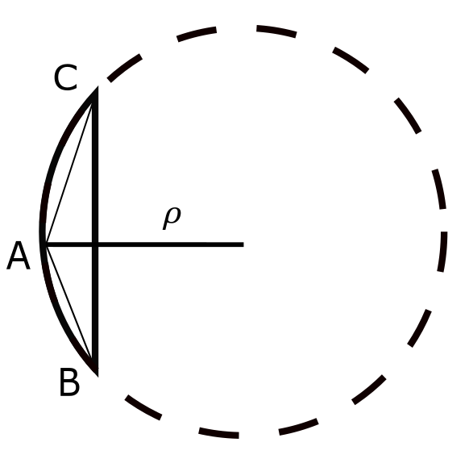

Figure . Scalene Triangle in Small Arc-Segment.

The application of this discrete radius of curvature and applying it to long-discrete arc segments as shown in Figure 8. This can be extended to the curvature $κ$ definition as shown in Figure 9. This method implies that for every three data points, a curvature point is defined, which is the minimum sampling frequency that this method can operate with. Other techniques can be applied to obtain the center of a circle given three data points that are sufficiently close together to be representative of the instantaneous change of curvature per segment. If the points are located close together then the change in curvature can be accurately identified.

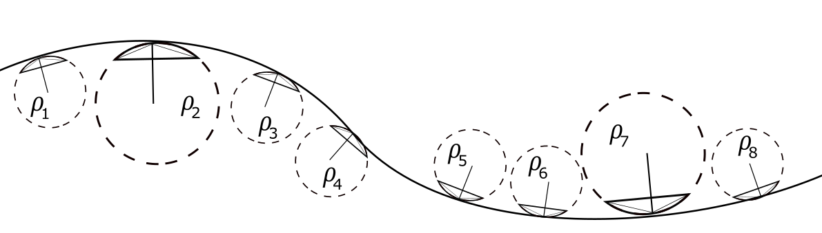

Figure . Road with Discrete Radius of Curvature Sections

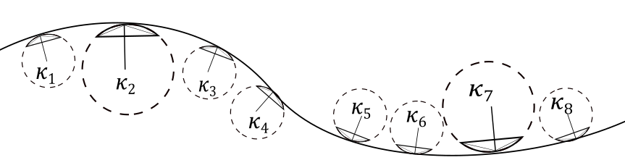

Figure . Road with Discrete Curvature Sections

With the use of different technologies such as Aerial Photography, LIDAR scanning, GPS collection, or Road Surveying, it is possible to obtain a discrete representation of the curvature profile needed to go through a road at every position within the road. The data points can be stored offline and represent the centerline of any road. Which can be then utilized with the road curvature decomposition to obtain, a representation of any road that complies with current design standards as per AASHTO. An example of the road curvature decomposition scheme is represented in Figure 10.

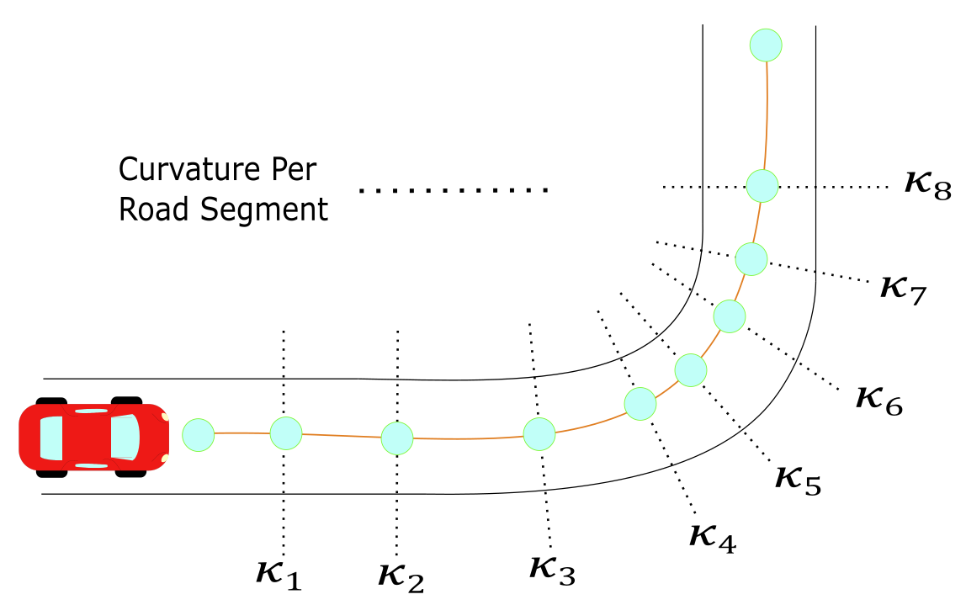

Figure . Road Curvature Decomposition Example

Heading Angle

To obtain the heading angle, two options were used. The first one comes from the well-established definition of heading angle from trigonometric relationships. The arc-length s of a curve is defined as the length traveled by a certain amount of degrees $θ$ along a constant radius $r$. If $s$ is sufficiently small, a triangle can be formed in between these three parameters, which are related through geometry:

$$\sin{θ}=\frac{s}{r}$$

Defining r as the radius of curvature at the specific arc-length and letting $r=ρ$.

$$\sin{θ}=\frac{s}{ρ}$$

By the previous assumption of small angles: $\sin{θ}=θ$, which leads to:

$$θ=\frac{s}{ρ}$$

Let the Curvature $κ$ be denoted by (#), and substituting this definition into equation (1)

$$θ=κs$$

Assuming a differential section for $θ$ and $s$. Rearranging for $κ$:

$$κ=\frac{dθ}{ds}$$

By separation of variables and integration

$$\int{κds}= \int{dθ}$$

Which concludes that the angle of orientation as a function of arc-length s can be found through numerical integration of the curvature as:

$$θ\left(s\right)= \int{κ\left(s\right)ds}$$

The second one involves an orthogonal phase shift to the curvature direction. Which by definition of the Frenet-Serret, can be obtained from the components of the curvature previously calculated in Equation (2). Using the discrete curvature formulation, the two heading angle calculations were implemented in the next section.

Implementations

Typical highway roads are designed based on AASHTO guidelines to provide a natural, easy-to-follow path for drivers, such that the lateral force increases and decreases gradually as the vehicle enters and leaves a circular curve [3]. This leads the advantage of generating curves based on AASHTO road geometry to obtain heading angles. The radius of curvature is computed from discrete points that represent coordinates of a road. To compare different approximations, different road identification methods were used. The first method involved a base model of the road based on AASHTO guidelines, and the second method involved using Google Earth coordinates.

AASHTO Base Model

This model consisted on strictly using AASHTO guidelines to design an ideal highway road for a vehicle traversing at constant 60 mph. The curve consisted of 5 different sections that can be classified as: straight section, entrance transition, constant radius curve, exit transition and straight section. Applying the discrete geometric approach to this curve, curvature vectors were plotted with respect to the road segments as shown Figure 9. The curvature magnitude was plotted with respect to road segments to obtain a base curvature profile as shown in Figure 10.



Figure . AASHTO Base Model: Road with Curvature Vectors.



Figure . AASHTO Base Model: Curvature κ vs. Cumulative Curve Length.

With the curvature profile established, two different approaches were used to confirm the heading angle approximation. One method involved obtaining the heading angle from trigonometric functions on the curvature vectors and add an orthogonal phase shift. The second method involved numerical integration of the curvature data to obtain a heading angle. The proof of the method is shown in Section 1.3 and both methods are shown in Figure 11 and Figure 12. Results on heading angles with respect to road segments are shown in Figure 13.



Figure . AASHTO Base Model: Orthogonal Phase Shift Approach.



Figure . AASHTO Base Model: Numerical Integration Approach.

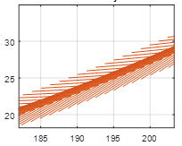

Figure . AASHTO Base Model: Road with Velocity Vectors.

Google Earth Model

This model is based off a selection of points in Google Earth that represent a highway road with design speed of 60 mph. The points were picked as close as possible to resemble the road centerline of the highway. The road profile and resulting vectors from applying the discrete geometry approach are shown in Figure 14. It is noticeable how the vector directions choose arbitrary tangent directions when the curve approaches a straight-line section. The curvature magnitude with respect to length was also plotted in Figure 15 and it was observed that magnitude deviations increased considerably compared to the ideal AASHTO model.



Figure . Google Earth Model: Road with Curvture Vectors.



Figure . Google Earth Model: Curvature κ vs. Cumulative Curve Length.

The method was not efficient in calculating curvature magnitudes, but the direction of the heading angle obtained from the orthogonal phase shift still provided comparable results to those found by calculating with AASHTO as shown in Figure 16. Similarly, the resulting velocity vectors to guide the vehicle provide a suitable heading direction as shown in Figure 17.



Figure . Google Earth Model: Orthogonal Phase Shift Approach.



Figure . Google Earth Model: Road with Velocity Vectors.

GPS Model

The last model is based off a GPS data set collected from a road with speed limit of 60 mph. The data was collected with a VC4000 Unit at a frequency rate of 10 Hz. This method was the least accurate given that the GPS has a static position error of about 1.981 m [22]. Figures 20-22 demonstrate the efficacy for the method to obtain heading angle vectors with GPS information. However, the method has a considerably less performance than other methods, unless different GPS accuracy is attained.



Figure . GPS Model: Road with Curvature Vectors.



Figure . GPS Model: Curvature κ vs. Cumulative Curve Length



Figure . Google Earth Model: Orthogonal Phase Shift Approach.

**

Figure . GPS Model: Road with Velocity Vectors.

Smoothing Techniques

On trajectory generation, many techniques focus on interpolation restrict the motion of vehicles to maintain certain level of commodity and stability [23][24]. Given that the approach presented obtains heading angle based on discrete data sets, smoothing techniques are needed to sustain a better approximation of road centerlines while offering a different option to store road decompositions.

Many methods such as Newton’s and Lagrange’s interpolation are used in fitting data for analysis [25]. However, for this application, Hermite or Osculatory Interpolation was selected to maintain a higher number of free parameters that provide monotonicity [25].

*Review of Alternative Methods*

Aside from the methods explored above, other suggestions for obtaining road data are provided. The methods vary on precision and have not been explored but will be evaluated in future work.

Aerial or Satellite Photography

Similar to Google Earth, this method requires identification (either manually or through software) of the lane. Often compatible with photo recognition techniques to evaluate road centerlines. The main disadvantage from this method is susceptibility to high tree density areas, road constructions, and environmental effects. Such effects can be earthquakes or flood washouts which may alter paths.

Survey, LIDAR, or Photogrammetry Point Clouds

Highest level of precision, but subject to considerable levels of noise. This noise can come from other vehicles, and reflective surfaces. Overall it offers the highest level of precision but requires costly implementations as well for nation-wide implementation.

Discussion/Recommendations

The study presented has the potential to be implemented on different areas in which path navigation is utilized. Such as unmanned aerial systems, or mobile robots. For this project, the route of autonomous vehicles is chosen to be the implementation of this technique. The advantages of this backup system rely on offering a backup system to the light and radar sensors on a vehicle. For example, on snow/rain conditions, the projected navigation path can provide a weighting factor on decision making for a given autonomous vehicle. To achieve this goal, the following scheme is proposed for an implementation of the discrete road decomposition as shown Figure 18. The first step involves collection of road data through any convenient means: GPS Data, Surveying, and Aerial Scanning. This road data contains a representation of the road centerlines which can be exported in different formats. These road centerlines are decomposed with the proposed method and then stored in a local infrastructure station. This infrastructure localizes and transmits the heading instructions for any upcoming vehicle through the designated road. Finally, a controller is developed to consider the heading based from the discrete road decomposition and navigate safely through the road.

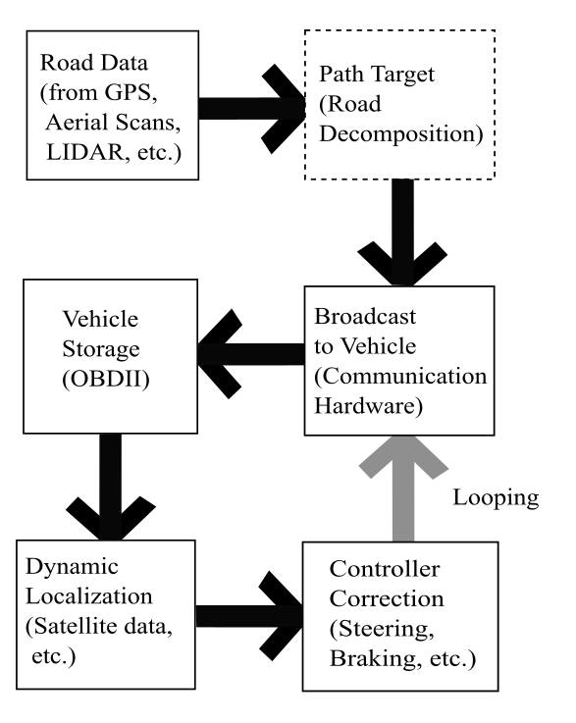

Figure . Implementation Scheme for Road Curvature Decomposition

Summary/Conclusions

In conclusion, a method was proposed to calculate trajectories based on curvature road data. Furthermore, the method exploits the perpendicular relationship in between the safe curvature design of any AASHTO designed road along with the heading angle of a vehicle. The method will be further explored with a refined/different data sets from other sources and testing for the feasibility of navigation. Similarly, more smoothing techniques such as Akima interpolation needs to be tested to provide the highest level of reliability for onboard driving. Successful implementation of this method could offer a new key piece to solve the autonomous vehicle paradigm under weather disruptions and/or other navigation technologies.

References

1. Gillespie, T. D. “Fundamentals of Vehicle Dynamics,” SAE Int. ISBN 1-56091-199-9, 1992.
2. Pacejka, H. B. Tyre and Vehicle Dynamics. Butterworth-Heinemann, 2006.
3. A Policy on Geometric Design of Highways and Streets, (The Green Book) 6th Edition. American Association of State Highway, 2011.
4. LaValle, Steven M. “Planning Algorithms,” 2006. <https://doi.org/10.1017/cbo9780511546877>.
5. Heinrich, S., “Planning Universal On-Road Driving Strategies for Automated Vehicles,” AutoUni – Schriftenreihe. Springer, 2018. <https://doi.org/10.1007/978-3-658-21954-3>.
6. Kelly, A., and Nagy, B., “Reactive Nonholonomic Trajectory Generation via Parametric Optimal Control.” I. J. Robotics Res. 22 (2003): 583–602. <https://doi.org/10.1177/02783649030227008>.
7. Dubins, L. E., “On Curves of Minimal Length with a Constraint on Average Curvature, and with Prescribed Initial and Terminal Positions and Tangents,” American Journal of Mathematics 79, no. 3 (1957): 497–516. <https://doi.org/10.2307/2372560>.
8. Ziegler, J., Bender, P., Dang, T., and Stiller, C., “Trajectory Planning for Bertha — A Local, Continuous Method.” In 2014 IEEE Intelligent Vehicles Symposium Proceedings, 450–57, 2014. <https://doi.org/10.1109/IVS.2014.6856581>.
9. Fox, C., “An Introduction to the Calculus of Variations. Courier Corporation,” 1987.
10. Takahashi, A., Hongo, T., Ninomiya, Y., and Sugimoto, G., “Local Path Planning And Motion Control For AGV In Positioning.” In Proceedings. IEEE/RSJ International Workshop on Intelligent Robots and Systems ’. (IROS ’89) ’The Autonomous Mobile Robots and Its Applications, 392–97, 1989. <https://doi.org/10.1109/IROS.1989.637936>.
11. Werling, M., Ziegler, J., Soren, K., and Thrun, S., “Optimal Trajectory Generation for Dynamic Street Scenarios in a Frenet Frame,” In 2010 IEEE International Conference on Robotics and Automation, 987–93. Anchorage, AK: IEEE, 2010. <https://doi.org/10.1109/ROBOT.2010.5509799>.
12. Werling, M., Kammel, S., Ziegler, J., Groll, L., “Optimal Trajectories for Time-Critical Street Scenarios Using Discretized Terminal Manifolds.” The International Journal of Robotics Research 31, no. 3 (March 2012): 346–59. <https://doi.org/10.1177/0278364911423042>.
13. Sun, Y., Zhan, Z., Fang, Y., Zheng, L. et al., “A Dynamic Local Trajectory Planning and Tracking Method for UGV Based on Optimal Algorithm,” 2019-01–0871, 2019. <https://doi.org/10.4271/2019-01-0871>.
14. Carmo, Manfredo P. Do. Differential Geometry of Curves and Surfaces. 1 edition. Englewood Cliffs, N.J: Prentice-Hall, 1976.
15. Pressley, A. N. Elementary Differential Geometry. 2nd ed. Springer Undergraduate Mathematics Series. London: Springer-Verlag, 2010. <https://doi.org/10.1007/978-1-84882-891-9>.
16. O’Reilly, Oliver M. Engineering Dynamics: A Primer. Springer Science & Business Media, 2010.
17. Are Mjaavatten (2019). Curvature of a 2D or 3D curve (https://www.mathworks.com/matlabcentral/fileexchange/69452-curvature-of-a-2d-or-3d-curve), MATLAB Central File Exchange. Retrieved May 24, 2019.
18. Sun, Y., Zhan, Z., Fang, Y., Zheng, L. et al., “A Dynamic Local Trajectory Planning and Tracking Method for UGV Based on Optimal Algorithm,” 2019-01–0871, 2019. <https://doi.org/10.4271/2019-01-0871>.
19. Piazzi, A., and C. Guarino Lo Bianco. “Quintic G2-Splines for Trajectory Planning of Autonomous Vehicles.” In Proceedings of the IEEE Intelligent Vehicles Symposium 2000 (Cat. No.00TH8511), 198–203, 2000. <https://doi.org/10.1109/IVS.2000.898341>.
20. Wilde, D., “Computing Clothoid-Arc Segments for Trajectory Generation,” In 2009 IEEE/RSJ International Conference on Intelligent Robots and Systems, 2440–45, 2009. <https://doi.org/10.1109/IROS.2009.5354700>.
21. Delingette, H., M. Hebert, and K. Ikeuchi. “Trajectory Generation with Curvature Constraint Based on Energy Minimization.” In Proceedings IROS ’91:IEEE/RSJ International Workshop on Intelligent Robots and Systems ’91, 206–11 vol.1, 1991. <https://doi.org/10.1109/IROS.1991.174451>.
22. William J. Hughes Technical Center, “Global Positioning System (GPS) Standard Positioning Service (SPS) Performance Analysis Report,” Federal Aviation Administration, 2017.
23. Levien, R. L., “From Spiral to Spline: Optimal Techniques in Interactive Curve Design,” n.d., 191.
24. Akima, H. “A New Method of Interpolation and Smooth Curve Fitting based on Local Procedures,” J. ACM 17, no. 4 (October 1970): 589–602. <https://doi.org/10.1145/321607.321609>.
25. Heath, Michael T. Scientific Computing: An Introductory Survey, Revised Second Edition. SIAM, 2018.

Contact Information

Contact details for the main author should be included here. Details may include mailing address, email address, and/or telephone number (whichever is deemed appropriate).

Acknowledgments

If the Acknowledgments section is not wanted, delete this heading and text.